**Practical No. 7**

1. **Working with Menus.**
2. **Options Menu**

**Designing UI**

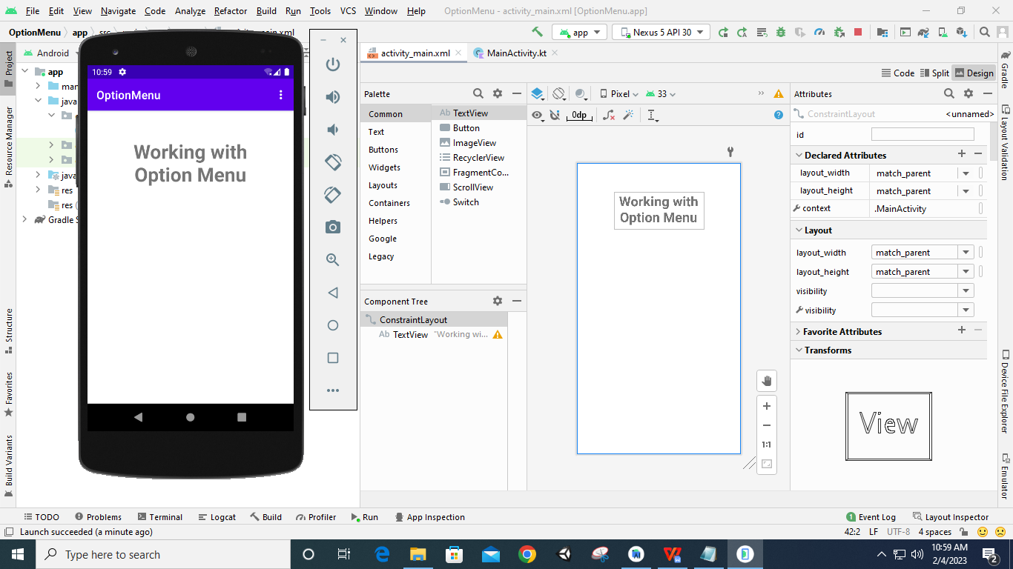

**Code:**

**package** com.example.optionmenu  
  
**import** androidx.appcompat.app.AppCompatActivity  
**import** android.os.Bundle  
**import** android.view.Menu  
**import** android.view.MenuItem  
**import** android.widget.Toast  
  
**class** MainActivity : AppCompatActivity() {  
 **override fun** onCreate(savedInstanceState: Bundle?) {  
 **super**.onCreate(savedInstanceState)  
 setContentView(R.layout.*activity_main*)  
 }  
  
 **override fun** onCreateOptionsMenu(menu: Menu?): Boolean {  
 **super**.onCreateOptionsMenu(menu)  
 createMenu(menu)  
 **return true** }  
  
 **fun** createMenu(menu: Menu?) {  
 **var** menu1: MenuItem? = menu?.add(0, 0, 0, **"Search"**)  
 **var** menu2: MenuItem? = menu?.add(0, 1, 1, **"Linked Devices"**)  
 **var** menu3: MenuItem? = menu?.add(0, 2, 2, **"Settings"**)  
 **var** menu4: MenuItem? = menu?.add(0, 3, 3, **"Exit"**)  
 }  
  
 **override fun** onOptionsItemSelected(item: MenuItem): Boolean {  
 **return** HandleMenuItemEvent(item)  
 }  
  
 **fun** HandleMenuItemEvent(item: MenuItem): Boolean {  
 **var** id: Int = item.*itemId* **when** (id) {  
 0 -> Toast.makeText(*applicationContext*, **"You Clicked Search"**, Toast.*LENGTH_LONG*).show()  
 1 -> Toast.makeText(*applicationContext*, **"You Clicked Linked Devices"**, Toast.*LENGTH_LONG*).show()  
 2 -> Toast.makeText(*applicationContext*, **"You Clicked Settings"**, Toast.*LENGTH_LONG*).show()  
 3 -> finish()  
 }  
 **return false** }  
}

**Output:**

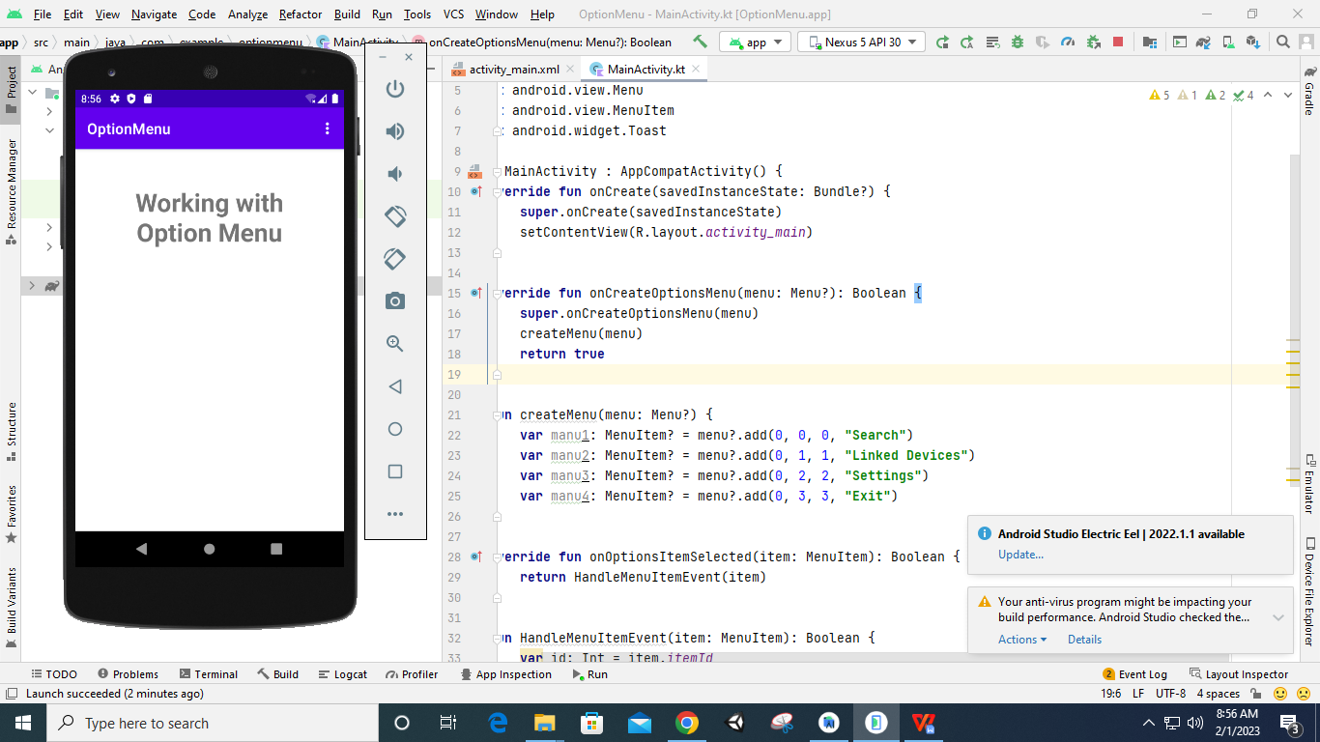

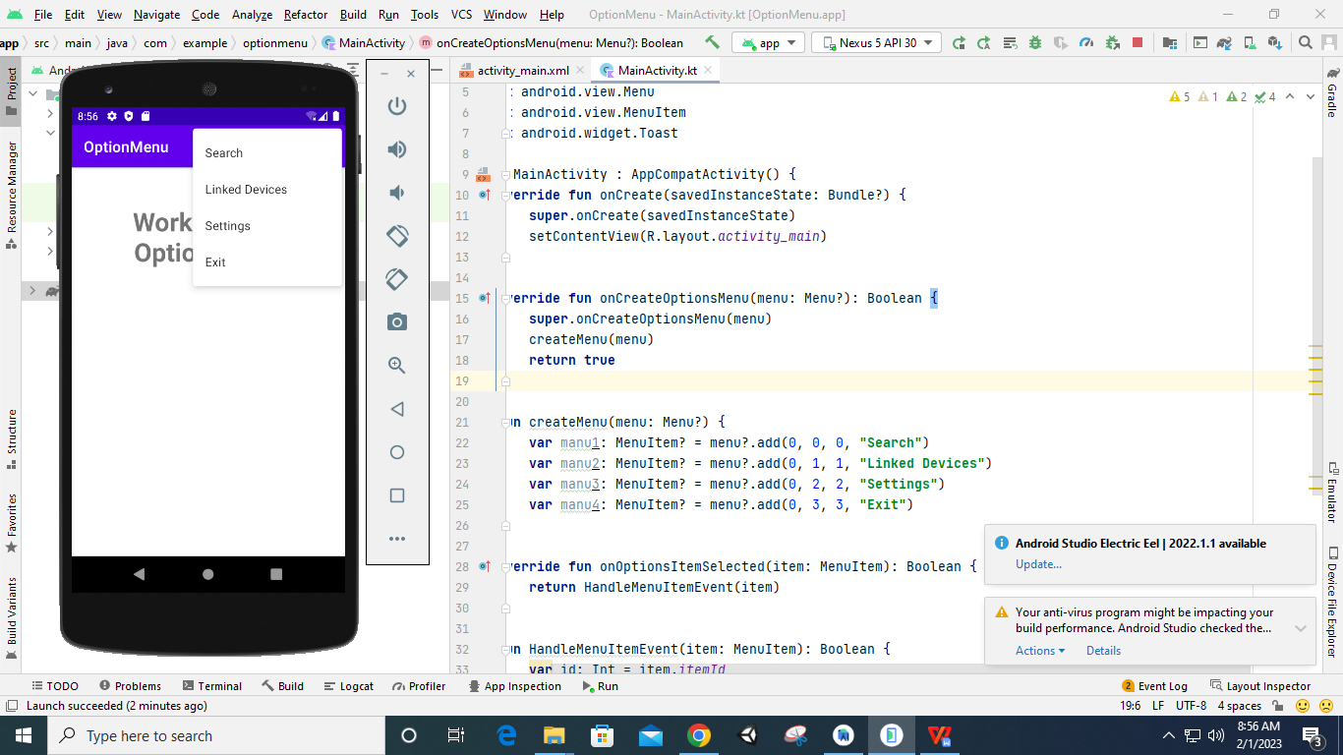

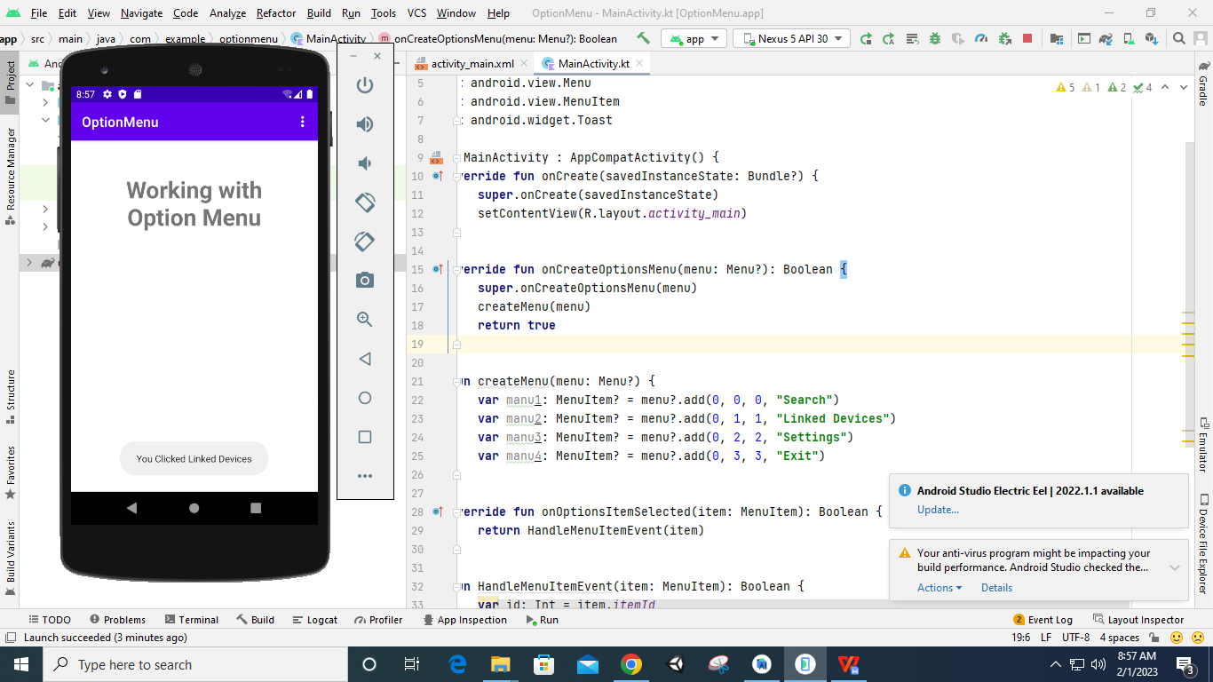

1. **Context Menu**

**Designing UI**

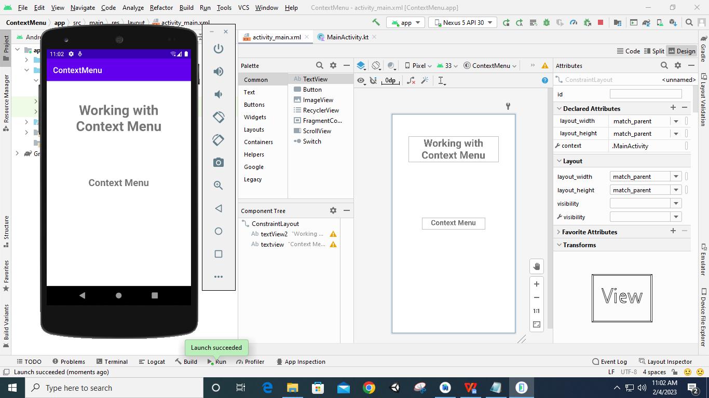

**Code:**

**package** com.example.contextmenu  
  
**import** androidx.appcompat.app.AppCompatActivity  
**import** android.os.Bundle  
**import** android.view.ContextMenu  
**import** android.view.MenuItem  
**import** android.view.View  
**import** android.widget.TextView  
**import** android.widget.Toast  
  
**class** MainActivity : AppCompatActivity() {  
 **override fun** onCreate(savedInstanceState: Bundle?) {  
 **super**.onCreate(savedInstanceState)  
 setContentView(R.layout.activity_main)  
  
 **var** text1: TextView =findViewById(R.id.textview)  
 text1.setOnCreateContextMenuListener(**this**)  
 }  
  
 **override fun** onCreateContextMenu(menu: ContextMenu?, v: View?, menuInfo: ContextMenu.ContextMenuInfo?) {  
 **super**.onCreateContextMenu(menu, v, menuInfo)  
 createContextMenu(menu)  
 }  
  
 **fun** createContextMenu(menu: ContextMenu?) {  
 **var** menu1: MenuItem? = menu?.add(0, 0, 0, **"Search"**)  
 **var** menu2: MenuItem? = menu?.add(0, 1, 1, **"Linked Devices"**)  
 **var** menu3: MenuItem? = menu?.add(0, 2, 2, **"Settings"**)  
 **var** menu4: MenuItem? = menu?.add(0, 3, 3, **"Exit"**)  
 }  
  
 **override fun** onContextItemSelected(item: MenuItem): Boolean {  
 **return** HandleContextItemClick(item)  
 }  
  
 **fun** HandleContextItemClick(item: MenuItem): Boolean {  
 **var** id: Int = item.itemId  
 **when** (id) {  
 0 -> Toast.makeText(applicationContext, **"You Clicked Search"**, Toast.LENGTH_LONG).show()  
 1 -> Toast.makeText(applicationContext, **"You Clicked Linked Devices"**, Toast.LENGTH_LONG).show()  
 2 -> Toast.makeText(applicationContext, **"You Clicked Settings"**, Toast.LENGTH_LONG).show()  
 3 -> finish()  
 }  
 **return false** }  
}

**Output:**

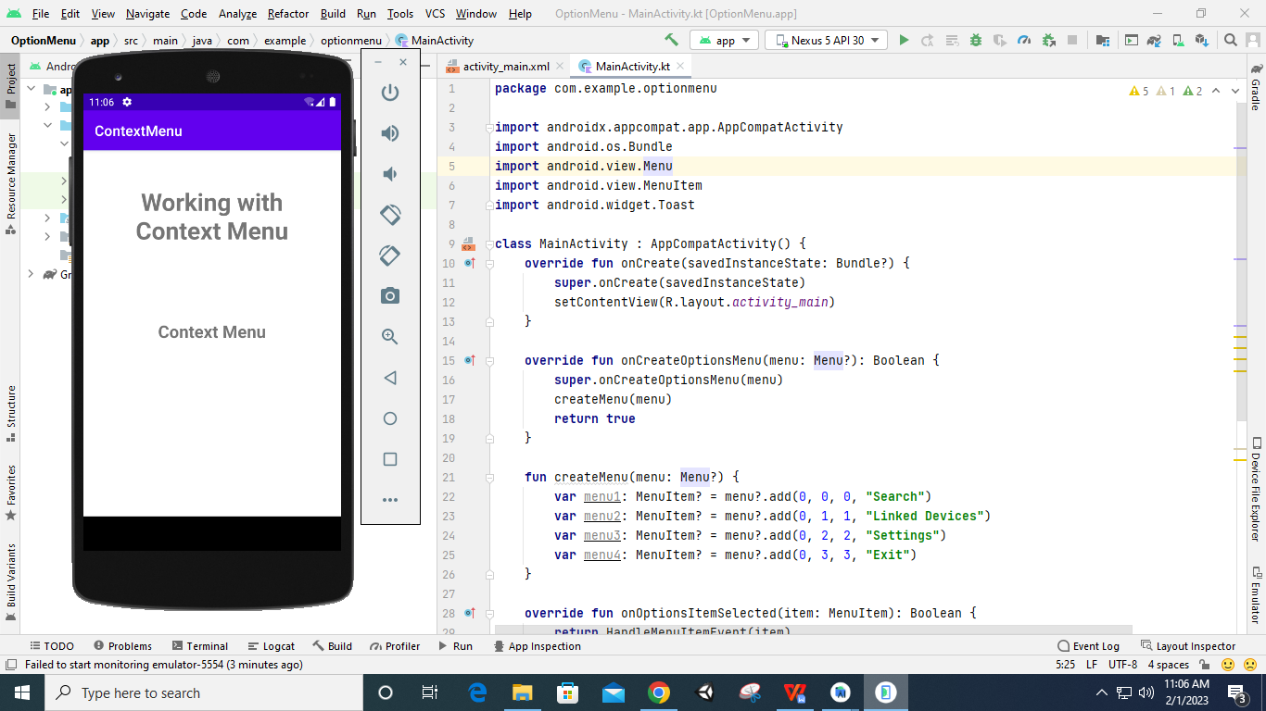

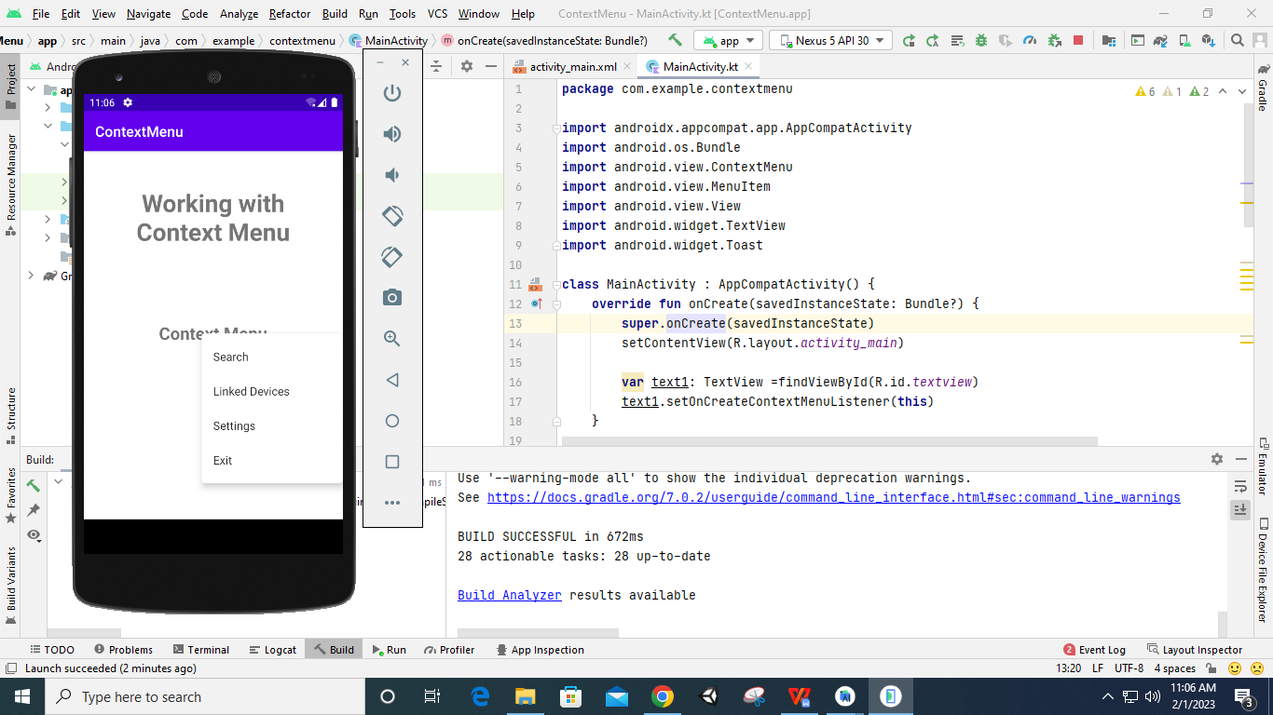

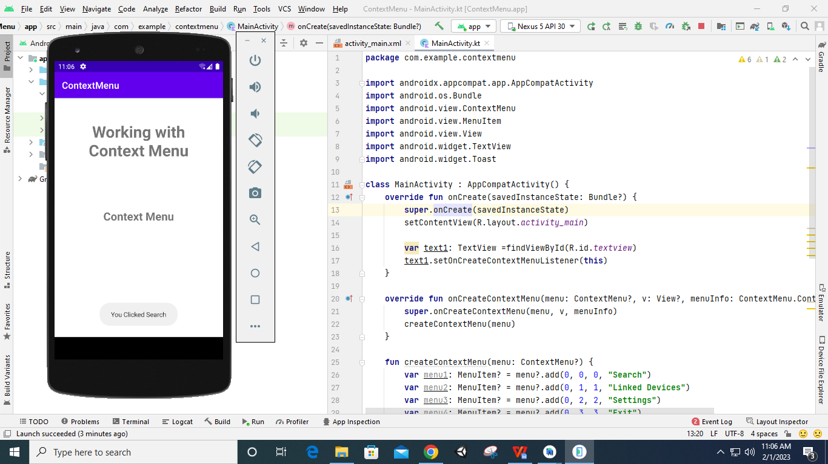

1. **Designing Menus in xml File**

**Designing UI**

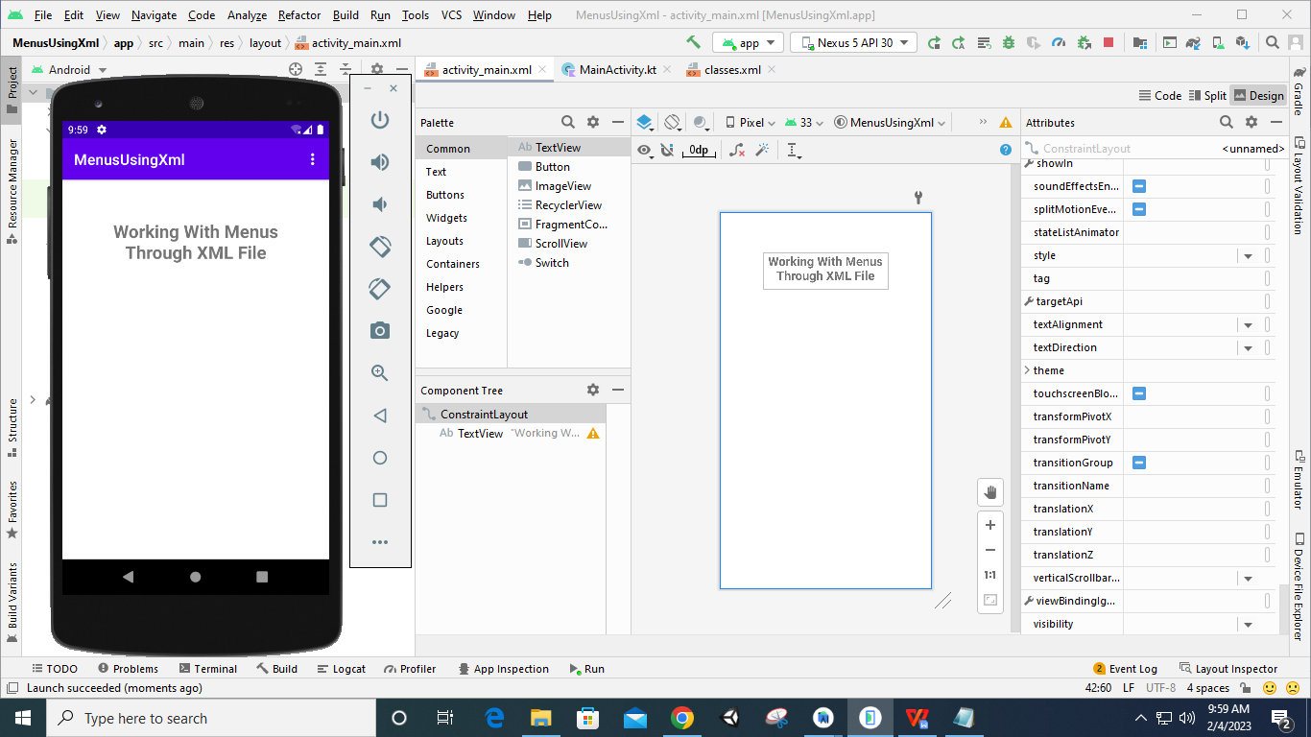

**Code:**

**Classes.xml**

*<?***xml version="1.0" encoding="utf-8"***?>*<**menu xmlns:android="http://schemas.android.com/apk/res/android"**>  
 <**item  
 android:id="@+id/item1"  
 android:title="FYCS"**>  
 </**item**>  
 <**item  
 android:id="@+id/item2"  
 android:title="SYCS"**>  
 </**item**>  
 <**item  
 android:id="@+id/item3"  
 android:title="TYCS"**>  
 </**item**>  
 <**item  
 android:id="@+id/item4"  
 android:title="Exit"**>  
 </**item**>  
</**menu**>

**MainActivity.kt**

**package** com.example.menususingxml  
  
**import** androidx.appcompat.app.AppCompatActivity  
**import** android.os.Bundle  
**import** android.view.Menu  
**import** android.view.MenuInflater  
**import** android.view.MenuItem  
**import** android.widget.Toast  
  
**class** MainActivity : AppCompatActivity() {  
 **override fun** onCreate(savedInstanceState: Bundle?) {  
 **super**.onCreate(savedInstanceState)  
 setContentView(R.layout.*activity_main*)  
 }  
  
 **override fun** onCreateOptionsMenu(menu: Menu?): Boolean {  
 **super**.onCreateOptionsMenu(menu)  
 createMenu(menu)  
 **return true** }  
  
 **fun** createMenu(menu: Menu?) {  
 **var** menuinflater: MenuInflater = *menuInflater* menuinflater.inflate(R.menu.*classes*, menu)  
 }  
  
 **override fun** onOptionsItemSelected(item: MenuItem): Boolean {  
 **return** HandleMenuItemEvent(item)  
 }  
  
 **fun** HandleMenuItemEvent(item: MenuItem): Boolean {  
 **return when** (item.*itemId*) {  
 R.id.*item1* -> {  
 Toast.makeText(*applicationContext*, **"You have Selected FYCS"**, Toast.*LENGTH_LONG*).show()  
 **true** }  
 R.id.*item2* -> {  
 Toast.makeText(*applicationContext*, **"You have Selected SYCS"**, Toast.*LENGTH_LONG*).show()  
 **return true** }  
 R.id.*item3* -> {  
 Toast.makeText(*applicationContext*, **"You have Selected TYCS"**, Toast.*LENGTH_LONG*).show()  
 **return true** }  
 R.id.*item4* -> {  
 finish()  
 **return true** }  
 **else** -> **super**.onOptionsItemSelected(item)  
 }  
 }  
}

**Output:**

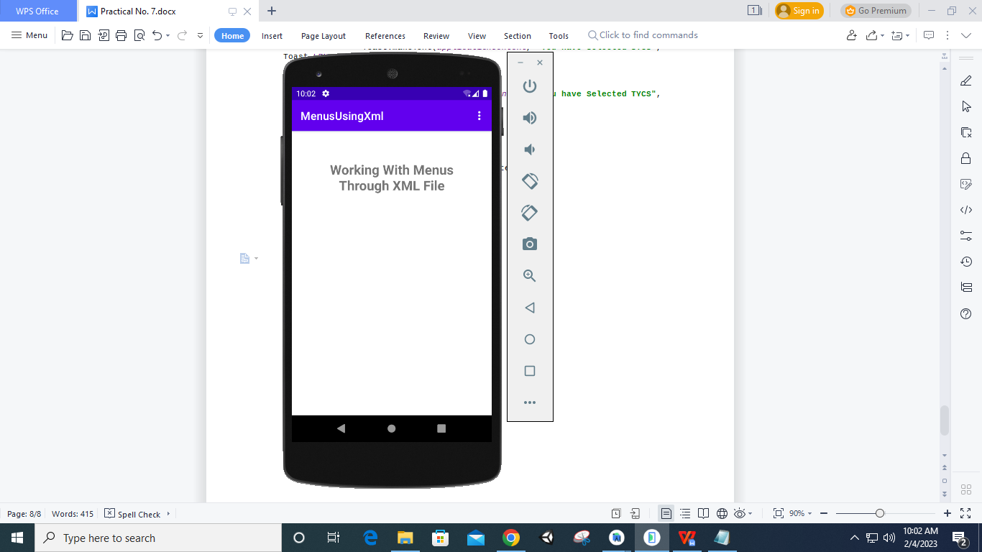

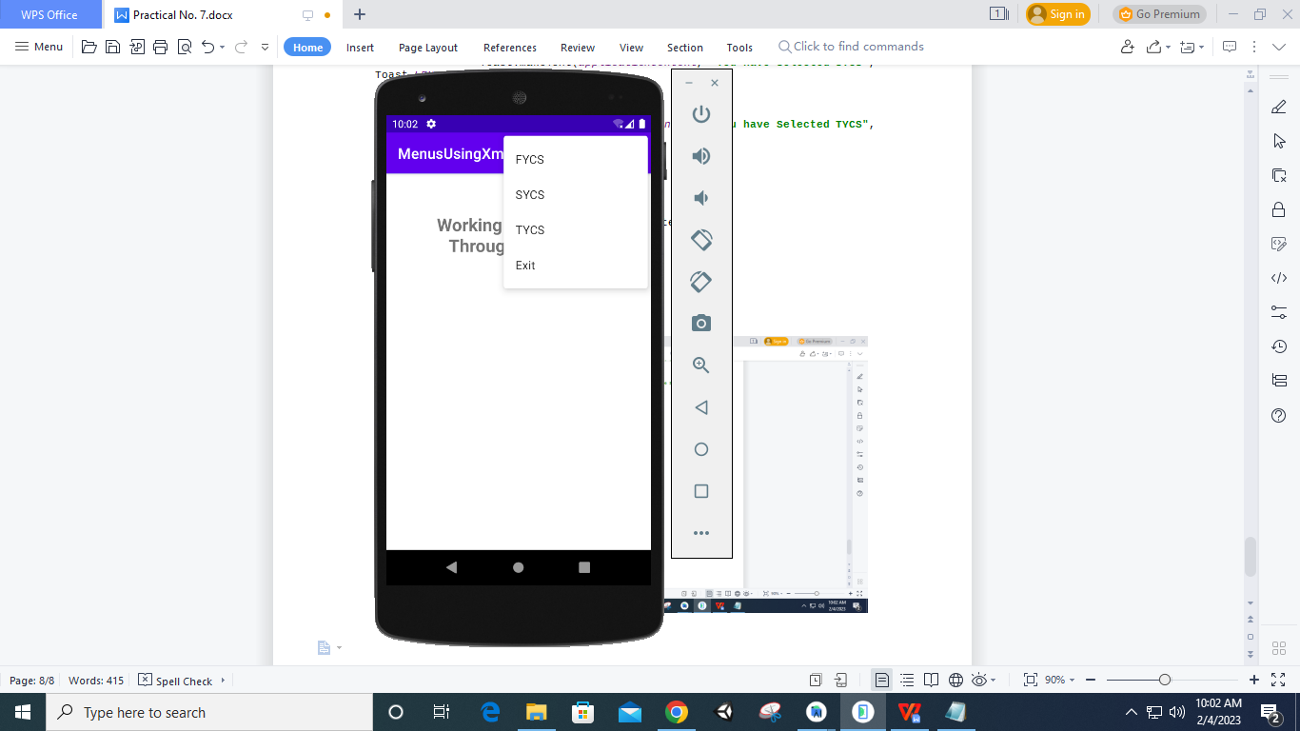

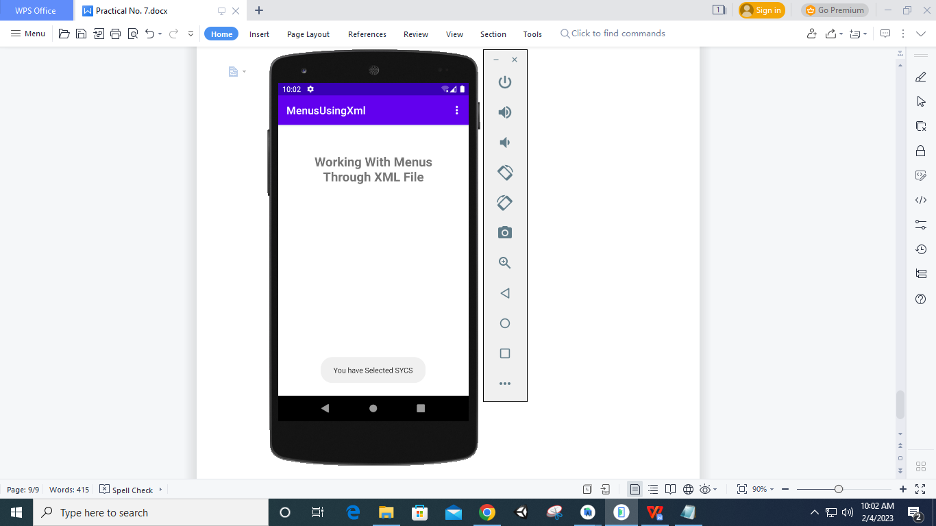

1. **Popup Menu**

**Designing UI**

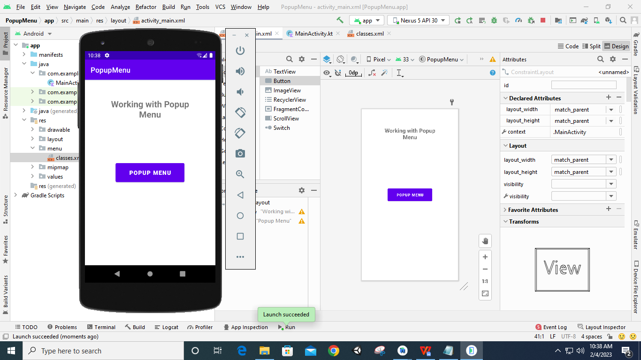

**Code:**

**Classes.xml**

*<?***xml version="1.0" encoding="utf-8"***?>*<**menu xmlns:android="http://schemas.android.com/apk/res/android"**>  
 <**item  
 android:id="@+id/item1"  
 android:title="FYCS"**>  
 </**item**>  
 <**item  
 android:id="@+id/item2"  
 android:title="SYCS"**>  
 </**item**>  
 <**item  
 android:id="@+id/item3"  
 android:title="TYCS"**>  
 </**item**>  
 <**item  
 android:id="@+id/item4"  
 android:title="Exit"**>  
 </**item**>  
</**menu**>

**MainActivity.kt**

**package** com.example.popupmenu  
  
**import** androidx.appcompat.app.AppCompatActivity  
**import** android.os.Bundle  
**import** android.view.Menu  
**import** android.view.MenuInflater  
**import** android.view.MenuItem  
**import** android.widget.Button  
**import** android.widget.PopupMenu  
**import** android.widget.Toast  
  
**class** MainActivity : AppCompatActivity() {  
 **override fun** onCreate(savedInstanceState: Bundle?) {  
 **super**.onCreate(savedInstanceState)  
 setContentView(R.layout.*activity_main*)  
  
 **var** btn: Button = findViewById(R.id.*button*)  
  
 btn.setOnClickListener **{  
 var** popup: PopupMenu = PopupMenu(**this**, btn)  
  
 popup.inflate(R.menu.*classes*)  
  
 popup.setOnMenuItemClickListener(PopupMenu.OnMenuItemClickListener **{** item **->  
 when**(item.*itemId*) {  
 R.id.*item1* ->  
 Toast.makeText(**this**, **"You have Selected FYCS"**, Toast.*LENGTH_SHORT*).show()  
 R.id.*item2* ->  
 Toast.makeText(**this**, **"You have Selected SYCS"**, Toast.*LENGTH_SHORT*).show()  
 R.id.*item3* ->  
 Toast.makeText(**this**, **"You have Selected TYCS"**, Toast.*LENGTH_SHORT*).show()  
 R.id.*item4* ->  
 finish()  
 }  
 **true  
 }**)  
 popup.show()  
 **}** }  
}

**Output:**

